Nitrogen supply and greenhouse gas emissions from a Black Vertosol amended with urea and ENTEC® urea

Constance M.Coverdale¹, Alice R. Melland², Diogenes L.Antille²

¹ University of Southern Queensland, Toowoomba, QLD, 4350, Australia, c.coverdale12@gmail.com
² University of Southern Queensland, National Centre for Engineering in Agriculture, Toowoomba, QLD, 4350, Australia

Abstract
The Australian cotton industry seeks ways to improve its nitrogen (N) use efficiency through strategies such as improving the timing and rate of soil and fertiliser N supply. This research compared the soil and fertiliser mineral N supply after application of urea and ENTEC® urea (which contains a nitrification inhibitor). Greenhouse gas emissions of nitrous oxide, methane and carbon dioxide were also compared. Data were collected by conducting a 60 day aerobic incubation of pots of a Black Vertosol soil under a constant air temperature (25ºC) and soil moisture range (>75% field capacity). The two N fertilisers were applied at 600 kg/ha N and were compared with an unfertilised control. Soil nitrate and ammonium concentrations and greenhouse gas fluxes were measured on up to nine occasions throughout the incubation. Mineral N supply from ENTEC® urea continuously increased over 60 days whereas the mineral N supply from urea peaked by day 14. The ENTEC® urea treatment also yielded 73% lower nitrous oxide emissions than the urea treatment. In the field, if N fertiliser was applied at cotton planting, the N supply from ENTEC® urea may better coincide with peak plant demands than urea.

Key Words
Cotton, Enhanced efficiency fertiliser, Soil mineral N, Nitrous oxide, Nitrogen-use efficiency.

Introduction
The cotton industry within Australia continuously strives for economic viability, long term productivity, sustainability and efficient farming practices to maintain international competitiveness. Further research into N use and application is important to meet these goals (Roth 2014). Nitrogen fertiliser inefficiency has been identified as having the potential to cost cotton growers up to $60 ha⁻¹ with denitrification identified as a key process causing N loss (Chen et al. 2008). On average, agricultural enterprises generate approximately 10 kg ha⁻¹ nitrous oxide per year with denitrification accounting for 50% of total N losses (Price 2006). The potential for enhanced efficiency fertilisers to reduce these losses within the Australian cotton industry is being investigated (e.g. Chen et al. 2008). In the 2014-15 season, 30% of Australian irrigated cotton crops received between 250 and 350 kg/ha of N and 50% of the crops received rates higher than 350 kg/ha of N (CRDC & CCA, 2015). Knowledge of the timing and rate of inorganic N supply from unfertilised and fertilised soil throughout a cotton season is still limited, however.

To help fill these knowledge gaps, this investigation compared the N release characteristics and greenhouse gas emissions (GHG) of standard urea with ENTEC® urea. ENTEC® urea is an enhanced efficiency fertiliser containing the nitrification inhibitor 3, 4-dimethylpyrazole phosphate (DMPP). The nitrification inhibitor is designed to delay the onset of nitrification by slowing the conversion of ammonium to nitrate by soil Nitrosomonas spp. bacteria after urea hydrolysis has occurred. The objective of this investigation was to identify the time of maximum net mineral N supply from a Black Vertosol amended with the two N fertiliser formulations, as well as to evaluate the effect of those formulations on GHG under controlled conditions of temperature and soil moisture.

Method
A Black Vertosol, representative of many cotton growing soils in Australia, was collected (depth range: 0-200 mm) from an irrigated cotton farm on the Darling Downs in south-east Queensland. Soil physical and chemical properties based on standard laboratory procedures were:
- Bulk density: 1.00 ± 0.03 g cm⁻³
- Field capacity (FC) moisture content: 40 %,
- Ammonium-N (NH₄⁺-N): 3.5 mg kg⁻¹,
- Nitrate-N (NO₃⁻-N): <0.5 mg kg⁻¹,
- pH: 8.4 ± 0.01

An aerobic incubation study was conducted to investigate the effects of fertiliser formulation on mineral N supply and GHG emissions under controlled conditions of moisture (between FC and 75% of FC) and temperature (25 ± 0.5 °C). A similar technique was used satisfactorily by Antille et al. (2014). For both urea and ENTEC® urea amended soils, fertiliser was applied at a field-equivalent rate of 600 kg ha⁻¹ of N, and there was also an unfertilised treatment (control). The applied fertiliser rate was about twice the rate commonly applied but this was required to allow un-ground fertiliser granules to be used and added in equal mass to each pot. The treatments were applied at the commencement of the incubation to four replicated pots of 300 g air-dried and sieved (<2 mm) soil. Pots were then wetted-up to reach field capacity and placed in the incubator for a period of 60 days. Soil was weighed and re-wetted every 2-3 days to maintain the target moisture condition, and was always wetted up the day before sampling. Sampling occurred on days 0, 3, 7, 14, 30, 45 and 60, and soil samples were analysed colorimetrically for mineral N (nitrate-N and ammonium-N) (Hach Company 2013 methods; Cadmium Reduction Method 8039, USEPA Nessler Method 8038). Greenhouse gases (N₂O, CH₄, CO₂) were sampled on days 1, 2, 3, 4, 5, 17, 46, and 60 using the static technique (Collier et al. 2014). Gas samples were extracted in a 25ºC laboratory at intervals of 0, 15, 30, and 45 minutes after sealing each pot, and analysed by gas chromatography. Subsequently, fluxes were estimated by assuming a linear increase of gaseous emission over each sampling period of 0-45 min for each pot and sampling day. A two-way ANOVA was undertaken with GenStat 16th Edition software (VSN International, 2014) to determine differences in soil mineral N concentrations and GHG fluxes. Least significant differences (5% level) were used to compare means.

Results and discussion

Soil mineral nitrogen
Measured concentrations of mineral N fractions were comparable across treatments, but absolute levels were higher than anticipated (by on average 30 mg kg⁻¹). This was attributed to interference by high chloride concentrations when using the Hach spectrophotometer methods. Overall, urea-treated soil had a significantly higher (P<0.05) supply rate of both NH₄⁺-N and NO₃-N than the control and ENTEC® urea-treated soil (Figure 1a-b). As expected due to inhibition of nitrification, urea supplied 1.8 times the amount of NO₃-N than ENTEC® urea over the 60-day period. However, rather than supplying concomitantly less NH₄⁺-N, urea also supplied 2.4 times the amount of NH₄⁺-N than ENTEC® urea. Trends of net ammonium and nitrate supply followed trends recorded in field trials for irrigated cotton (e.g., Chen et al. 2008). The unfertilised control soil had low mineral N concentrations, possibly due to rapid immobilisation under the prevailing experimental conditions (Tejada et al. 2002). The low mineral N supply was not likely to be due to low microbial activation associated with the short pre-incubation wetting period because there was no evidence of increasing activation during the incubation. Kliese et al. (2005) indicated a potentially mineralisable N amount of between 110-270 mg kg⁻¹ is typical for a Black Vertosol, which was not found in this investigation.

The peak ammonium concentration occurred by day 7 for both urea (325 mg kg⁻¹ of N) and ENTEC® urea (237 mg kg⁻¹ of N). This is indicative of urea hydrolysis occurring in both fertiliser treatments. However, the higher (P<0.05) ammonium concentration in the urea treatment than the ENTEC® urea treatment cannot be explained as both fertilisers were fully incorporated into the soil to prevent ammonium volatilisation. Fifty percent of the total nitrate supply from urea occurred by day 7 (205 mg kg⁻¹ of N), and supply peaked by day 14 (398 mg kg⁻¹ of N). Peak nitrate supply from ENTEC® urea fertiliser however, was delayed until at least day 60, with approximately 75% of the total supplied by day 30 (253 mg kg⁻¹ of N). The difference in the timing of peak nitrate supply between the two treatments may be partially attributed to the effect of the nitrification inhibitor in ENTEC® urea, which delayed the conversion of ammonium-N into nitrate-N until later in the incubation period. However, the rapid, rather than gradual, exhaustion of ammonium in the ENTEC® urea treatment was not consistent with the gradual increase in nitrate. The peak nitrate requirement of cotton occurs between 50 and 100 days after crop emergence. Therefore, a delay in the peak supply of nitrate from a single application of fertiliser may help better match N supply to crop N demand in the field.

Greenhouse gas emissions
There were significant differences in N₂O emissions between treatments (P<0.05) (Figure 2). Average daily emissions of N₂O -N were in the order: control (0.32 g ha⁻¹), ENTEC® urea (0.70 g ha⁻¹), and urea (1.91 g ha⁻¹). Nitrous oxide emissions from urea-treated soil equated to about 0.02% of total N applied as fertiliser. The above results were consistent with data reported in the literature (e.g., Snyder et al. 2009; Chen et al. 2008a). Despite the higher than typical rates of N applied, emissions from both urea and ENTEC® urea fertilisers in this investigation were well below the national guideline of approximately 1.25% emission per unit of N applied.

Urea produced similar average fluxes of CO₂ per sample time (168 μg CO₂-C m⁻²) compared with ENTEC® urea (586 μg CO₂-C m⁻²) over the 60-day period (P>0.05). These emissions, which extrapolated to 40-141 g ha⁻¹ d⁻¹ were low compared with daily emissions measured from clayey loam field plots of cereal grains in a cooler environment (Weiske et al. 2001). The unfertilised control soil showed a net absorption of CO₂ with an average daily flux of -160 g ha⁻¹ CO₂-C. There were no significant differences in CH₄ emissions between treatments. Average daily CH₄ emissions were 0.02, 0.04, and 0.11 g ha⁻¹ C for the control, urea, and ENTEC® urea treatments, respectively. These levels of methane emissions are considered to be low and are explained by the fact that the experiment was conducted under aerobic conditions (Serrano-Silva et al. 2014).
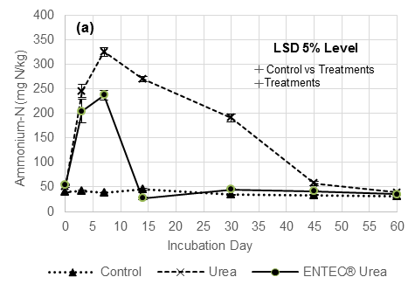
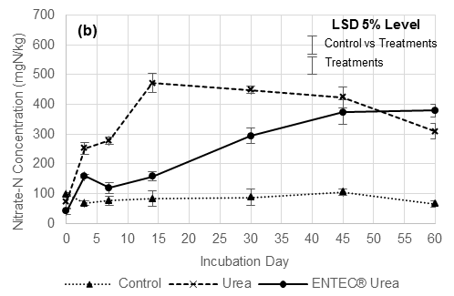

Figure 1: Soil ammonium (a) and nitrate (b) concentration of control, urea and ENTEC® urea treatments over 60 day incubation period. Errors bars indicate ± 1 S.E.M. LSDs at 5% confidence interval and are shown for the control vs urea and ENTEC® urea, as well as the urea vs ENTEC® urea comparisons.

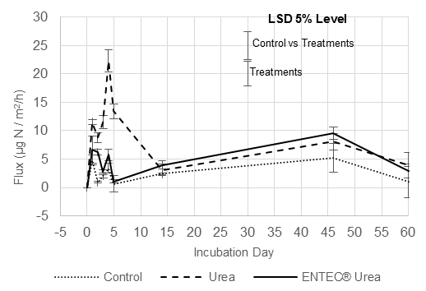
Figure 2: Nitrous oxide emission fluxes for control, urea and ENTEC® urea treatments over a 60 day incubation period. Errors bars indicate ± 1 S.E.M. LSDs at 5% confidence interval and are shown for the control vs urea and ENTEC® urea, as well as the urea vs ENTEC® urea comparisons.

Conclusion
Peak nitrate N supply after urea application occurred 14 days after application whereas nitrate supply from ENTEC® urea increased throughout the 60 day incubation. Nitrous oxide emissions of urea fertiliser also exceeded the emissions of ENTEC® urea by 73% over the 60 day aerobic incubation period. Methane and CO₂ emissions were low from all treatments. The results suggest that the enhanced efficiency fertiliser, ENTEC® urea, may provide better synchrony of N supply and cotton crop N demand if applied in the field at or before cotton planting, as well as reduce impacts on the environment from GHG emission. Investigation is required into the cost-benefit ratios of using ENTEC® urea as an alternative N fertiliser to urea and the effect on CO₂ emissions and nitrification rates when urea and ENTEC® urea are applied in the field.

References
Antille DL, Sakrabani R, Godwin RJ (2014) Nitrogen Release Characteristics from Biosolids-Derived Organomineral Fertilizers. Communications in Soil Science and Plant Analysis 45(12), 1687-1698.
Chen D, Freney JR, Rochester I, Constable GA, Mosier AR, Chalk PM (2008) Evaluation of a polyolefin coated urea (Meister) as a fertilizer for irrigated cotton. Nutrient Cycling in Agroecosystems 81(3), 245-254.
Collier SM, Ruark MD, Oates LG, Jokela WE & Dell CJ (2014) Measurement of Greenhouse Gas Flux from Agricultural Soils Using Static Chambers. Journal of Visualised Experiments 90
CRDC & CCA (2015). Qualitative Report on the 2014–15 cotton season: A survey of consultants; Cotton Research and Development Corporation: Narrabri, Australia.
Griffin, T 2008, Nitrogen Availability (Chapter 15), Nitrogen in Agriculture Systems, Schepers, JS & Raun, WR (eds.), Agronomy Monograph 49.
Hach Company (2013) Hach DR2700 User Manual, 4th edn., Germany.
Kliese YJ, Dalal RC, Strong WM, Menzies NW (2005) Piggery pond sludge as a nitrogen source for crops. 1. Mineral N supply estimated from laboratory incubations and field application of stockpiled and wet sludge. Australian Journal of Agricultural Research 56(3), 245-255.
Price, G (ed.) 2006, Australian Soil Fertility Manual, 3rd edn., Fertilizer Industry Federation of Australia Inc., CSIRO Publishing, Collingwood.
Rayment G, Lyons D (2011) Soil Chemical Methods – Australasia, CSIRO Publishing, Collingwood, Australia.
Roth G (2014) Australian Grown Cotton Sustainability Report 2014, Cotton Australia, CRDC, Australian Government.
Serrano-Silva N, Sarria-Guzman Y, Dendooven L, Luna-Guido M (2014) Methanogenesis and Methanotrophy in Soil: A Review. Pedosphere 24(3), 291-307.
Snyder CS, Bruulsema TW, Jensen T, Fixen PE (2009) Review of greenhouse gas emissions from crop production systems and fertilizer management effects. Agriculture, Ecosystems and Environment, 133(3-4), 247-266
Tejada M, Benitez C, Gonzalez JL (2002) Nitrogen mineralization in soil with conventional and organomineral fertilization practices. Communications in Soil Science and Plant Analysis 33(19-20), 3679-3702
VSN International 2014, Genstat 17th Edition, UK.
Weiske A, Benckiser G, Herbert T, Ottow JCG (2001) Influence of the nitrification inhibitor 3,4-dimethylpyrazole phosphate (DMPP) in comparison to dicyandiamide (DCD) on nitrous oxide emissions, carbon dioxide fluxes and methane oxidation during 3 years of repeated application in field experiments. Biology and Fertility of Soils 34(2), 109-117.

