Soybean (Glycine max) response to rhizobia inoculation and soil nitrogen

Catherine Mathenge^{1, 2}, Moses Thuita², Joseph P Gweyi-Onyango¹ and Cargele Masso^{2*}

¹Department of Agricultural Science and Technology, Kenyatta University, P.O BOX 43844-00100, Nairobi, Kenya
²International Institute of Tropical Agriculture, c/o ICIPE, P.O. Box 30772-00100, Nairobi, Kenya
*corresponding author: C.Masso@cgiar.org

Abstract
Inoculation of soybean is an efficient way of increasing effective rhizobia population in the rhizosphere, but the performance is limited by soil fertility including nitrogen and carbon levels. Objective of the study was to determine the performance of soybean inoculation on soils of variable levels of nitrogen (N) and organic carbon (Corg) and its improvement through soil N and Corg amendment. Two greenhouse trials were set up and a field trial. The first greenhouse trial included unamended sixty soils (i.e. N: 0.03-0.21 %; organic carbon ≤ 2.10%), with and without inoculation. Sympal a blended fertilizer recommended for legumes was used for the inoculated treatments. The 2nd trial consisted of two soils selected based on the results of the first trial (i.e. 0.06% and 0.08% N) and amended with five rates of vermicompost (Phymyx) to various N levels (i.e. N: 0.06/0.08-0.21%), with and without inoculation. The results of the 2nd greenhouse trial were validated in field conditions using similar treatments. For the sixty soils, the correlation between soil N and the growth parameters was low because of variability in other soil properties (r: 0.29-0.55). Nodule weight, biomass and N uptake increased due to soil amendment. There was a significant interaction effect of soil and inoculation for N uptake (p<0.001) as a result of the differences in soil properties, while the starter N from vermicompost did not hinder the performance of the rhizobia inoculant. This study demonstrated that amending soils of low N content with vermicompost can significantly increase soybean nodulation, shoot biomass, N uptake, and grain yield at p < 0.05.

Keywords: Soybean, inoculation, Legumefix, nitrogen, vermicompost.

Introduction
Rhizobia inoculation on legume seeds for biological nitrogen fixation represents a hallmark of successfully applied agricultural microbiology (Bruno et al., 2003). Inoculation of legumes such as soybean with rhizobia has been widely recognized, especially in areas where soybean has been newly introduced. Effective Rhizobium inoculants would result in reduction of inorganic nitrogen (N) fertilizer use by farmers in legume production. Furthermore, it has been reported that legume crops enrich the fertility of the soil, which generally benefit the cereal crops when rotation is practiced. However, success of rhizobia inoculation depends on the optimal interaction of legume genotype, rhizobia strain, the environment, and crop management (Woomer et al., 2014).
The N-fixing potential of legumes is expected to be high when soil mineral N is low compared to richer soil conditions (Naudin et al., 2010). Soil organic carbon also has a significant effect on soil fertility including rhizobial populations (Swanepoel et al., 2011). In general, total N and soil organic matter are highly correlated. In low organic matter soils, organic amendments can act as source of nutrients, improve soil structure, increase biodiversity and activity of the microbial population (Albiach et al., 2000; Liu et al., 2008). However, the common practice of legume inoculation in most sub-Saharan countries focuses on rhizobia inoculants and phosphorus (P) fertilizers irrespective of the overall soil fertility including total soil N and organic matter. The current variable response to inoculation therefore calls for further research to inform the use of rhizobia inoculants. The objective of the study was to determine the critical range of N outside which, response to inoculation is hindered, and the effect of N containing organic amendment on the performance of inoculation in soils with low initial N and organic C.

Materials and methods

First greenhouse trial
Sixty soils were collected at a depth of 0 - 20 cm at which most soil biological activity occur and gives a reasonable reach of most plant nutrients in selected farms in different locations of Siaya County in Kenya. Sub samples were analysed for physical and chemical properties and the rest used for the greenhouse trial at International Centre of Insect Physiology and Ecology, Nairobi. Plastic pots with a capacity of about 2 kg were perforated at the bottom and 2 kg of soil weighed into each. Sympal (23P: 15K + 10CaO + 4S + 1MgO + 0.1Zn) at a rate of 30 kg P ha-1 was applied to the inoculated pots. Soybean variety TGx1740-2F was used. The rhizobia inoculant was Legumefix (Bradyrhizobium japonicum strain 532c). The experiment was a Complete Randomized Design (CRD) with three replicates, with and without inoculation. Nodule fresh weight (NFW) and shoot dry weight (SDW) were determined at 50% podding to inform the 2nd greenhouse trial.

Second greenhouse trial
Two soils (i.e. 0.06 % - 0.08 % N) from the 1st greenhouse trial were selected. These were among the soils that showed low response to inoculation. The two soils were amended with vermicompost, after its characterisation. Vermicompost was applied at 5 rates (including a zero) of even intervals, with the maximum rate increasing the tested soils N level to 0.21%. The experimental design was a CRD and treatments were similar to the 1st greenhouse trial. In addition to NFW and SDW, N uptake (Nup) was determined at 50% podding.

Field trial
This was designed to validate the findings of the 2nd greenhouse trial at the two sites where the soils of 0.06 % and 0.08 % N were collected. It has been set in a split plot design arrangement at each site. The main plot included Sympal at the rate used in the 2nd greenhouse trial. The sub-plots consisted of vermicompost at 5 levels (including a zero), with and without inoculation, in a full factorial with three replicates. In field conditions, the maximum rate of vermicompost has been limited to 10 metric tons ha⁻¹ to reflect the current use of organic amendment in Kenya. Urea plus Sympal has been used as a positive reference. Data collection include NFW, nodule effectiveness, SDW, and N_{up} at 50% podding, physiological nitrogen use efficiency as well as grain yield at harvest.

Data Analysis
Analysis of variance using the mixed procedure of the SAS System (version 9.4) at a significance level of P<0.05 has been used to evaluate the treatment effects. The standard error of the difference (SED) has been used to separate the means when applicable.

Results and discussion

First greenhouse trial

Nodule fresh weight and SDW for the sixty soils were poorly correlated to the soil total N (r: 0.29-0.44 and r: 0.37-0.55 respectively) as shown with selected representative soils in Fig 1 and 2. This was attributed to variation in the physical and chemical properties across the sixty soils [data not shown for all soils but two (Table 1)]. When soils of different composition are used, it would be difficult to determine the critical levels of N for effective soybean inoculation. The high nodule weight to shoot weight ratio confirmed soybean is highly dependent on N fixation (16% inoculated and 15% without inoculation). However, responses in soils with N ≥ 0.17% were steady and relatively better than in the low N soils. Two soils in the low N category were therefore selected for the 2nd greenhouse trial for amendment with an organic source of N (i.e. vermicompost) to determine the suitable N levels for soybean inoculation when the soil properties are less variable. The high correlation of total N and organic C in the sixty soils (r = 0.94) substantiated the choice of an organic source of N.

Second greenhouse trial
Table 2 shows soybean performance in the two soils with and without inoculation in terms of NFW, SDW, and N_{up}. The general trend in the data was a slight decrease of NFW, SDW, and N_{up} at soil N level above 0.17%. Only one data point was available after soil N = 0.17%; hence, there will be a need to investigate further data points around it so as to confirm it as the threshold value above which, application of an N source would hinder soybean response to inoculation. Within the experimental range (0.06/08-0.21% N), it was not possible to determine the N level below which, there would be non-response to inoculation unless a starter N is added, since there was response at all N levels (Table 2). Further investigation using soils of N levels lower than 0.06% will be required. The significant interaction effect of the soil and the inoculant confirmed that the success of legume inoculation depends on soil conditions (Table 3). The soil with N = 0.08% performed better, which was consistent with the good chemical properties when compared to the soil of N = 0.06% (Table 1). Based on SDW and N_{up}, vermicompost did not negatively affect the response to inoculation (Table 3). In low N soils, the use of an organic N source would not hinder the performance of rhizobia inoculants in soybean when proper rates are used; it would conversely improve nodulation (Table 2; Table 3).

Conclusion
Nitrogen levels in soils of different physical chemical properties were not suitable to assess the critical N values below and above which soybean response to rhizobia inoculants would be hindered. Amendment of low N soils with vermicompost showed that an N level of 0.17% in clayey soils is a potential threshold value above which additional application of N to the soils would negatively affect soybean response to inoculation. Further investigation with additional data points around it, is however still required for confirmation. The N value below which no soybean response to rhizobia inoculants would be expected without starter N would be below 0.06% as the effective nodulation was found between 0.06 - 0.21% N; further investigation is recommended. Response to inoculation was affected by the soil properties, whereas the use of a starter N in the form of vermicompost improved their soybean response compared to unamended soils. The grain yields in the field trial were in line with greenhouse trial with a slight decreased when the vermicompost was raised from 7.5t to 10t ha⁻¹.

List of Tables
Table 1. Selected physical and chemical properties of the two soils and vermicompost
Property | Units | Soil 1 | Soil 2 | Vermicompost
pH(H₂O) |  | 4.52 | 5.43 | 6.7
Available P | (mg kg⁻¹) | 3.06 | 119.77 | 0.39
Ca | (mg kg⁻¹) | 0.85 | 5.49 | 0.29
Mg | (mg kg⁻¹) | 0.33 | 1.51 | 0.1
K | (mg kg⁻¹) | 0.21 | 0.26 | 0.22
Organic C | (%) | 0.80 | 1.05 | 7.31
Total N | (%) | 0.06 | 0.08 | 0.88

Table 2. Effect of soil N amendment and inoculation on nodulation, biomass and N uptake at 50% podding
 | Soil 1 (0.06% N) |  |  |  | Soil 2 (0.08% N)
Soil N (%) | Inoculated | Non- inoculated |  |  | Inoculated | Non- inoculated
Nodule fresh weight (g plant⁻¹)
0.06/0.08ª | 1.2 ± 0.8 |  | 0.4 ± 0.3 |  | 3.1 ± 0.5 | 0.5 ± 0.5
0.10 | 5.5 ± 2.9 |  | 7.8 ± 0.8 |  | 7.9 ± 1.3 | 5.9 ± 1.1
0.14 | 6.4 ± 1.0 |  | 9.4 ± 0.2 |  | 7.9 ± 0.5 | 10.5 ± 0.7
0.17 | 10.1 ± 0.6 |  | 10.4 ± 1.0 |  | 12.5 ± 0.9 | 11.7 ± 2.4
0.21 | 9.8 ± 1.2 |  | 10.6 ± 0.5 |  | 11.2 ± 2.7 | 11.1 ± 3.4
Shoot dry weight (g plant⁻¹)
0.06/0.08ª | 1.69 ± 0.8 |  | 0.96 ± 0.8 | 15.76 ± 0.7 |  | 4.9 ± 0.5
0.10 | 12.64 ± 0.4 |  | 15.2 ± 0.6 | 24.72 ± 2.5 |  | 20.09 ± 3.2
0.14 | 18.41 ± 0.1 |  | 18.15 ± 1.8 | 23.89 ± 1.6 |  | 18.24 ± 1.5
0.17 | 19.33 ± 0.9 |  | 20.11 ± 1.2 | 25.35 ± 3.4 |  | 21.56 ± 4.0
0.21 | 20.34 ± 0.5 |  | 19.88 ± 1.1 | 25.14 ± 2.0 |  | 21.56 ± 4.4
N uptake (g plant⁻¹)
0.06/0.08ª | 0.03 ± 0.01 |  | 0.01 ± 0.01 |  | 0.27 ± 0.01 | 0.08 ± 0.01
0.10 | 0.22 ± 0.01 |  | 0.22 ± 0.01 |  | 0.44 ± 0.04 | 0.36 ± 0.06
0.14 | 0.32 ± 0.00 |  | 0.31 ± 0.03 |  | 0.42 ± 0.03 | 0.32 ± 0.03
0.17 | 0.34 ± 0.02 |  | 0.35 ± 0.02 |  | 0.45 ± 0.06 | 0.38 ± 0.07
0.21 | 0.36 ± 0.01 |  | 0.35 ± 0.02 |  | 0.35 ± 0.04 | 0.44 ± 0.01
ª0.06 for Soil 1 and 0.08 for Soil 2

Table 3.Statistical assessment of the various treatment effects
Effect | Nodule fresh weight | Shoot dry weight | N uptake
Soil (S) | ** | *** | ***
Vermicompost (V) | *** | *** | ***
Inoculant (I) | NS | *** | ***
S × V | NS | *** | *
S × I | * | *** | ***
V × I | * | NS | NS
S × V × I | * | NS | NS
Significance levels: NS: p≥0.05; *: p<0.05; **: p<0.01; ***: p<0.001

List of figures
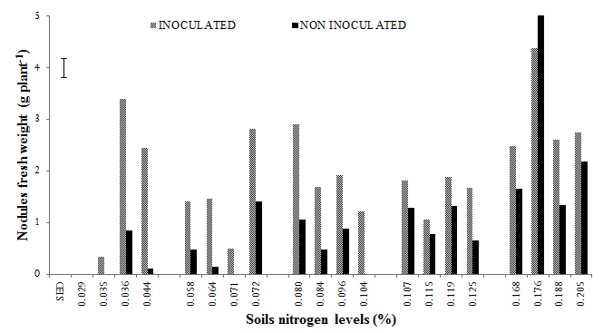
Fig.1 Responses of soybean inoculation with Bradyrhizobium japonicum strain 532c on nodules fresh weight as affected by different soil nitrogen levels for selected 20 soils (out of the 60 soils) used in the greenhouse trial

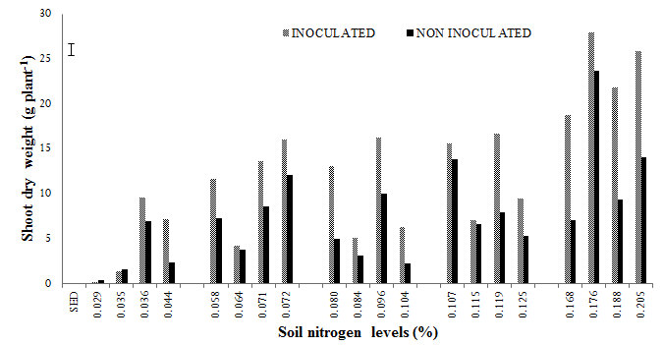
Fig.2 Responses of soybean inoculation with Bradyrhizobium japonicum strain 532c on shoot dry weight as affected by different soil nitrogen levels for selected 20 soils (out of the 60 soils) used in the greenhouse trial

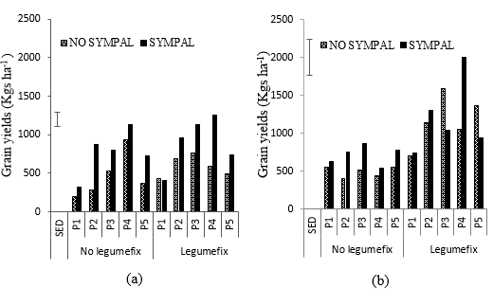

Fig. 3 Interactive effects of sympal, Legumefix and soil N amendment with vermicompost (Phymyx) on grain yields under field conditions (a) 0.06%N and (b) 0.08%N.

References
Albiach et al., 2000. Bioresource Technology, 75(1), pp.43-48.
Bruno et al., 2003. Trends in Ecology & Evolution, 18(3), pp.119-125.
Liu et al., 2008. Plant production science, 11(3), pp.271-277.
Naudin et al., 2010. Field Crops Research, 119(1), pp.2-11.
Swanepoel et al., 2011. African Journal of Range & Forage Science, 28(3), pp.121-127.
Woomer et al., 2014. www.N2africa.org, pp. 138

